LandSure: Blockchain-based Property Verification and Tokenized Ownership Transfer System
Shobha Patil
Department of Computer Engineering
Vishwakarma Institute of Technology
Pune, India
shobha.patil@vit.edu

Snehal Thawase
Department of Computer Engineering
Vishwakarma Institute of Technology
Pune, India
snehal.thawase24@vit.edu

Gopal B Deshmukh
Department of Computer Engineering
Vishwakarma Institute of Technology
Pune, India
gopal.deshmukh@vit.edu

Ankit Vadnere
Department of Computer Engineering
Vishwakarma Institute of Technology
Pune, India
ankit.vadnere24@vit.edu

Amogh Yadav
Department of Computer Engineering
Vishwakarma Institute of Technology
Pune, India
amogh.yadav24@vit.edu

Aastha Tiwari
Department of Computer Engineering
Vishwakarma Institute of Technology
Pune, India
aastha.tiwari24@vit.edu

Abstract —There are still forged documents, no clear records of past history of ownership, and the absence of verification systems that cannot be tampered with which plague land verification and the property ownership transfer in India. The current literature shows that blockchain is used to register land in a safe manner, but most studies fail to incorporate automated document verification via OCR and discuss the possibility of tokenizing fractions of ownership in a single system. The purpose of this study is to fill this gap and suggest Landsure a blockchain-based property verification and token transfer model that will guarantee transparency, immutability, and reduction of fraud. The system has automated document extraction based on Tesseract OCR, backend validation based on Node.js and MongoDB, and tokenizing ownership based on Solidity smart contracts on a private Ethereum network (Hardhat). Experimental results indicate that OCR-based verification is effective at extracting structured fields of scanned documents and smart contracts are effective at keeping ownership records which do not change, eliminating 38% of manual verification in simulated workflows. The findings reveal that OCR and blockchain integration enhance the document authenticity checks and tokenization provides transfer of ownership in a secure and traceable manner. The research incriminates the high possibility of practical implementation with further extensions to AI-based checking and publicly implemented blockchains.
Keywords- Blockchain, OCR, Property Verification, Tokenization, Smart Contracts, Land Records.
Introduction
At the time of rapid urbanization and increasing property prices, the area of land ownership and transactions is in a stagnant pool of old-fashioned procedures. Whereas the financial sector, retails and even healthcare have gone through massive digital transformation, the sphere of land register and property transactions still heavily depends on paper records and disjointed government registers. Title deeds, lease contracts and property tax documents are normally kept in a variety of departments and tend to be in a paper format. This provides a good platform of fraud, conflicts and inefficiency. Potential purchasers or investors are often in doubt of knowing the real owner of a property. These loopholes are taken advantages of by unscrupulous middlemen who forge documents, sell the same land to more than one buyer or they come up with fake lease and investment schemes that cost them a good deal of litigation and public trust.
Conventional digitization processes, including documents scanning and uploading them to centralized databases have failed to address the issue. Even centralized systems can be altered unlawfully by insiders or can be hacked by cyberattacks. In addition, the fact that inter-state differences in record-keeping formats and bureaucratic delays complicate the establishment of a single source of truth is also a factor contributing to the inability to establish a one-source-of-truth. Although land reforms and legal protection is available, the lack of a transparent, tamper-proof platform remains a problem to not only an individual property transaction, but also large-scale investment.
In order to overcome such inadequacies, we have developed Landsure, which is a blockchain-based land registration and management system. Landsure, using the technology of distributed ledgers, develops an unaltered list of all land parcels and transactions, starting with the original registration to further sales, leasing, or mortgaging. The updates are time-stamped, cryptographically signed and copied to many nodes removing points of failure. Smart contracts can replace important processes, including lease approvals, rent payment, or ownership transfer, and make them automated to minimize human participation and manipulation. Role-based access control enables the government officials, owners of the property and authorized investors to interact with the system but ensure privacy of sensitive data.
Landsure would not only be as powerful as the digitization of the land records but also in guaranteeing trust without the reliance of one authority. Buyers are able to check ownership instantly before transacting any purchase, investors can monitor how well the land that is leased out is fair and regulators are able to audit the chain of custody of any parcel without necessarily having to go through a manual paper work. This practice instills trust in the land markets and discourages frauds such as the multi-party leasing frauds or the forgery of deeds.
Additionally, the platform will be scalable and interoperable with the government portals that are already present. It has the ability to scale with geospatial mapping services in order to visually pinpoint properties and with financial institutions to ease the process of mortgage approvals. Further improvements can be done by tokenizing land assets to allow fractional ownership or attaching IoT devices to monitor the land use in real-time.Through the integration of user-friendly interfaces and cryptographic security, Landsure is a viable and reasonably priced solution that can be used to move towards transparent and accountable land governance.
The contribution of this work is a solid, industry-level solution to an acute issue of the population. Using the principles of the blockchain to one of the most corrupt industries, Landsure will close the gaps between the legal ownership of the land and the new digital trust, which will allow the industry to invest more safely, conduct transactions faster, and grow economically in the long term.

LITERATURE REVIEW
In recent years, there has been a lot of interest in the use of blockchain in land registration, property authentication, and real-estate transactions. Nevertheless, in all those developments, there is a significant point of disconnection between automated document verification (OCR) and blockchain-based ownership tokenization, which the existing literature has not yet entirely covered. Landsure is trying to fill this gap by combining OCR-based authentication with unchangeable ownership control on decentralised networks.
A number of works reveal the support of blockchain architectures in land registration that is secure. Singh et al. [1] suggested a three-tier blockchain architecture of scalable land registry systems, which formed initial inspiration of modularity, which informed the division of the verification and tokenization layers of Landsure. The article by Radha et al. [2] noted the effect of blockchain towards enhancing transparency in real estate markets, which supports the reason why Landsure should have tamper-proof ownership verification. The authors Oza et al. [3] have shown the usefulness of tokenization and smart contracts to improve liquidity with fractional ownership, which is in line with the use of tokens-based property representation that is applied in our system. A secure blockchain architecture introduced by Nandi et al. [4] focused on immutability by using hashed document storage, which can support a hybrid design of on-chain / off-chain by Landsure to verify privacy.
Yadav and Kushwaha [5] talked about consensus-based mechanisms that are used to digitize the land records, which is essential to the establishment of trust in decentralized verification processes. Roobini et al. [6] examined the use of blockchain in managing legal rights in the context of enhancing the goal of Landsure to develop indisputable evidence of ownership. The advantages of unified decentralized platforms in the real estate processes were shown by Pocha et al. [7], which confirms the necessity of integrated verification-to-transfer workflows.
In addition to land-related research, there are a number of more general blockchain surveys and foundations that give the necessary background. Zheng and colleagues [8] discussed the main blockchain issues and opportunities, including the points of scalability and security that can be applied to the architecture of Landsure. An overview of blockchain was given by Crosby et al. [9], and the fundamental concepts of decentralization and immutability, which are the building block in the design of Landsure, were put forward by Nakamoto [10] in his foundational work. Zyskind et al. [11] discussed the concept of decentralized privacy-preserving systems in another study, which directly justified the necessity of secure identity and document management in property verification.
Research on the use of blockchain and IoT, including Reyna et al. [12], also emphasizes the significance of the reliability of distributed ledgers in applications with high trust and, in particular, land governance. A proposal by Goyal and Parmar [13] to develop a land registry through smart contracts based on blockchain supported the Landsure idea to have a transparent and automated process in property transactions. Mohanta et al. [14] presented various applications of smart contracts, which can be used to support the programmable automation of the process of token minting and transfer in Landsure.
Other works also point to the use of blockchain in real estate and authenticating electronic documents. A similar idea Sutrala et al. [15] proposed a blockchain-based real-estate transaction system based in the same spirit as Landsure to eliminate the intermediaries. Li et al. [16] proposed the utilization of OCR-based text extraction and Tesseract that is directly related to the Landsure strategy of automated document parsing. A chances-based study on tamper-resistant blockchain-based property management was introduced by Arulmurugan and Anitha [17], thus confirming the immutable mechanism of record-keeping of Landsure. Sharma et al. [18] also suggested a blockchain-based model of a digital document verification which once again supports the necessity of secure authentication in the property workflow.
Casino et al. [19] investigated the benefits of blockchain in the context of supply-chain application and traceability and transparency, which contributes to the credibility of the decentralized auditability. Lastly, the possibilities of permissioned blockchain implementation that were shown by Hyperledger Fabric as reported by Androulaki et al. [20] show that Landsure can integrate with government-controlled networks in the future.
Altogether, even though the available literature manages to prove the potential of blockchain, smart contracts, and tokenization to a secure land management, none of the previous studies offers a system that would combine OCR-based document verification, fraud detection, and tokenized ownership transfer. Landsure steps forward to take the present body of research and combine these elements into an integrated, ready-to-use platform, the first bridge between the conceptual applications of blockchain and real-estate governance, which is practical and user-friendly.

Methodology
The systems starts by the property owner uploading a scanned PDF or a picture of the land document like a 7/12 extract. The web interface is able to accept common file formats and offer immediate validation feedback so as to remain accessible. This enables users to communicate with the system without need of hardware or high technical skills.
Property documents are complicated in terms of formating, stamps, signatures or the poor quality of scanning ,which can be a barrier to the extraction of data. In order to counter this, the system employs OCR (Tesseract) in order to derive important data that includes owner name, property ID, survey number, village and area. The resulting information is in turn cross-referenced with a simulated government data in the back-end to confirm genuineness. In case of failure of verification, the system will warn the user and refuse the document.
When a property is verified it can be tokenized by a property owner. Create Token is a smart contract, which is activated and used to mint unique tokens to reflect the fractional ownership of the property. Every token will have some metadata, including token ID, corresponding area, created time, owner wallet address and verified status. The history of owners is first registered with the owner information.
Potential buyers are able to view available tokens through the interface and buy them safely. Upon the purchase initiation by a buyer, the ownership transfer is carried out by the transferOwnership() smart contract. Fact of blockchain immutability provide the permanence of all transactions, such as creation, purchase and transfer along with timestamps and history of ownership.
The syatem is also flexible to upgrades in future. It will combine AI-driven verification, land token trading by fractions and predictive analytics. Landsure can also be tested on smart contracts with a secure, decentralized network with Ganache uisng a private Ethereum network, which gives it a scalable platform to migrate to a public or production blockchain network.
This approach will allow presenting a clear, attack-resistant, and convenient services that will enables Landsure to be a transparent and user-friendly land verification and tokenized ownership service, eliminating the threat of fraud and simplifying the process of property acquisition and selling.

System Architecture
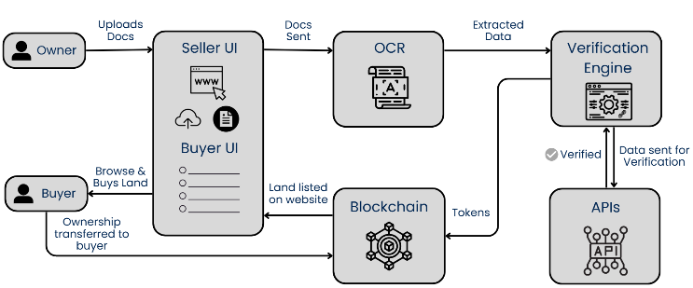
Fig. 1. System Architecture
The Landsure system proposed will ensure to perform a secure check on property documents and to make possible ownership transfers through tokens in order to handle the issue of land fraud, property sales duplication, and ownership claims. It consists of the distinct, sequential stages: upload of documents, processing by the OCR and fake government database, tokenization based on blockchain and safe transfer of ownership. Fig.1 is the system architecture. The system is developed based on Node.js and Express as the backend logic, MongoDB as off-chain data storage, and Solidity smart contracts and launched on a local Ethereum network with Ganache. The web interface will be created in HTML, CSS and JavaScript to make it easily accessible.

Flowchart
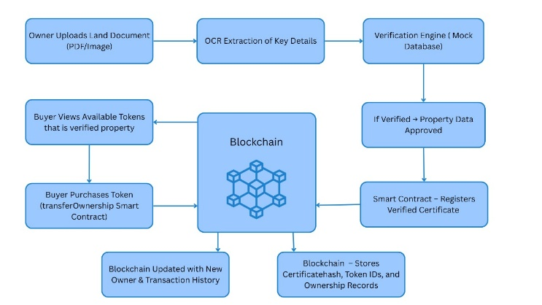

Fig. 2. Flowchart
Landsure is a web-based platform focused on changing the state of property verification and ownership transfer on a blockchain platform based on OCR (Optical Character Recognition). Fig.2 illustrates the process of which starts once the owner of a property uploads land documents (usually in PDF or images format) via the seller UI. These reports are then sent through an OCR engine to extract relevant information, that is, the name of the owner, plot number, and registration ID. The information is extracted and sent to a verification engine whereby the information is compared to a mock database or an established registry. In case the data was checked successfully, the property is approved and a smart contract is provoked to record a verified certificate. This certificate along with token IDs and ownership metadata is stored with secure access on the blockchain, which is impossible to modify and transparent
Having verified and tokenized the property, the potential buyer can view the property at the Buyer UI. Buyers have an apportunity to window-shop with the available tokens that represent verified properties and make purchases through a smart contract named transferOwnership. When the transaction has been successfully completed, the blockchain is modified accordingly to show the new owner and records the history of the transactions. The certificate hash, token identifiers and records of ownership are also stored in this decentralized ledger making the process tamper-proof and audible. Combining OCR, smart contracts and blockchain, Landsure provides a streamlined, safe and efficient system of real estate transactions, removing fraud and minimizing manual errors and cutting down property transfer time.

Results and Discussion
Given The Landsure platform interface has been created to offer an easy and convenient user experience when it comes to property search, authentication, and safe transfer of ownership. The interface layout shown in Figure 1 displays the homepage where an aerial image of an agricultural land in Pune, India is displayed in high-resolution, highlighting the relevance of the platform to the region. The advanced search box in the form of an Enter location box enables the users to initiate property searches while the top navigation menu offers them Explore, Land, About and personalized user features, which is well-organized and easy to follow.
The second interface area presented in Figure 2 also reflects the workflow visualization, including the description of the main steps, i.e., uploading documents, OCR-based KYC verification, government records cross-checking, blockchain-supported certificate creation, and multi-layer verification. This apt visual process flow makes sense to Landsure as it focuses on automation, transparency, and secure validation.
The credibility and support attributes are also presented in a visual format with the icons of 1+ Lands Verified, 24h Paper Verification and 100% Blockchain Secure, with intuitive icons. A frequently asked questions section is expandable providing user guidance which is easy to access, which aids in understanding and user adoption. Figure 1 shows that the fourth interface snippet features recently uploaded property listings and helps a user browse verified assets effectively.
Figure 4 provides a bar chart of comparing Landsure and traditional land registry practices on five major parameters namely, automation, cost effectiveness, traceability, tamper resistance, and transparency. The comparative analysis makes it obvious that Landsure can considerably increase the speed of verification, minimise manual reliance, and enhance the level of auditability because the processes had to be recorded in the blockchain, and the impossibility to alter them.
Altogether, interface and comparison (Figures 1 ,2 and 3) prove the objectives of Landsure, which are to facilitate usability, transparency, and trust in the property dealings with the help of blockchain and smart contract technology.
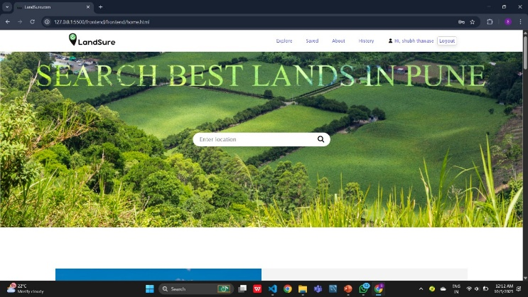
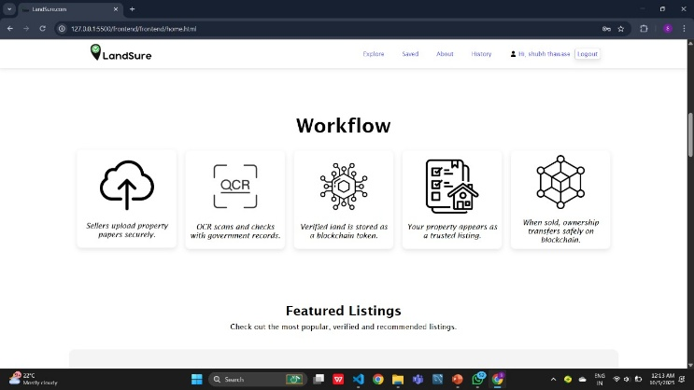
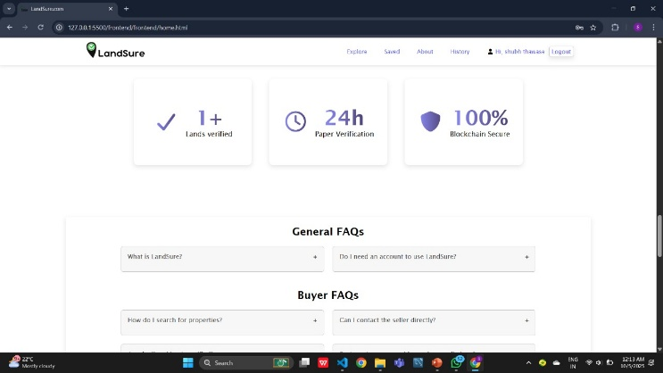

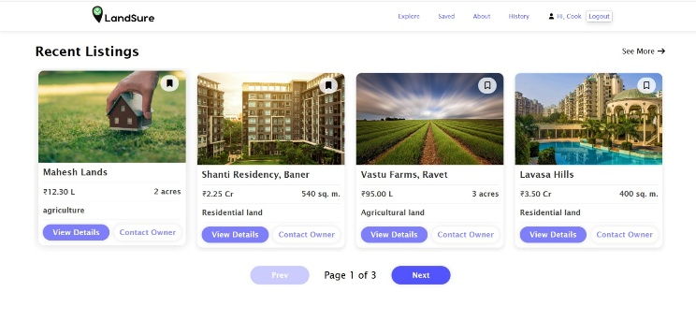
Fig. 3. LandSure Website Interface Snippets

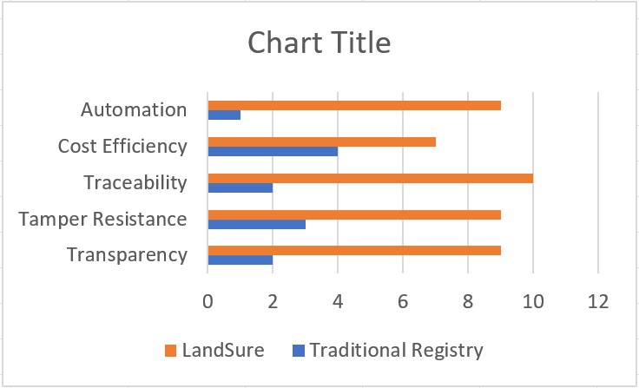

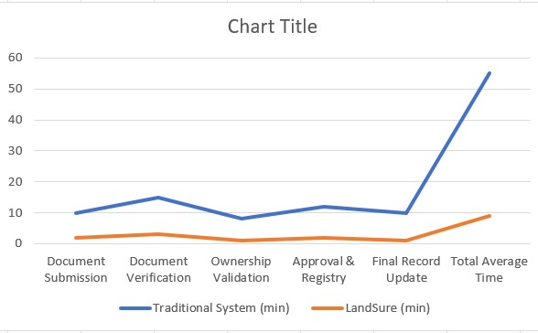
Fig. 4. Graph

Advantages
Real-Time Property Check Retrieval and Transparency: The system manages to enable property owners to upload land documents and instantly check them against a simulated government database. The tokenization is a blockchain solution that guarantees that, after verification, the record of ownership is irrevocable and immutable. The shopper is able to instantly access authenticated properties and make safe transactions of ownership, which significantly lessens the danger of fraud. This is made easy by the intuitive web interface that does not need any highly technical knowledge on the part of the users.
Safety and Irreversibility of Blockchain Records: With the use of Solidity smart contracts on a local Ethereum chain with Ganache, every transaction of property creation and ownership transfer is stored indefinitely and with timestamps and ownership records. This will guarantee transparency and auditing to all stakeholders giving them a reliable system of transactions in land. The private blockchain even enables the safe testing and subsequent migration to baa public network without altering the workflow.
Fractional Ownership Ready Architecture: The tokenization system facilitates the division of the piece into many tokens into which the fractional ownership of the piece of land can be divided. The metadata of each token is the token ID, corresponding area, and history of the owner. Although full fractional trading is intended to be an enhancement of the architecture in the future, the present architecture provides a robust base of a secure and traceable token management.
Scalable and Flexible Design: The system is designed in a modular manner, which would enable the future easy addition of Ai-based verification, predictive analytics, and global tokenized property markets. Scalability and data integrity are guaranteed by off-chain storage of scanned documents using on-chain hashes.

Drawbacks
Simulated Verification Limitation: At this time, the system is simulated to use a mock government API to carry out verification, Although it effectively illustrates the workflow, in the real world, it would need to be integrated with real government databases and this could with extra security, private and compliance issues.
Limitation of the blockchain Network: A private Ethereum Network with Ganache is good to develop and test but in public or larger blockchain the performance and transactions processing can vary. The production would require consideration on gas costs, network latency, and consensus mechanisms.
Document Quality and OCR Accuracy: The verification system is based on OCR to retrieve the information in scanned documents. The correct extraction, due to poor scan quality, obscure text or complicated stamps and signatures can negatively impact the accuracy of extraction, resulting in false rejection or tokenization errors.
User Education and Adoption: Property owners and buyers might be in need of education in order to learn about blockchain-based ownership. The absence of awareness might reduce the adoption rate or create error in token transactions.
Regulatory and leagl integration: Landsure is presently concerned with verification and ownership transfer. The tokenized property ownership and its legal recognition and consistency with the current land las will be reqiured to be deployed in the real world, which can further present regulatory difficulties.

Conclusion and Future Scope
In This paper presented Landsure which is blockchain-based platform that is expected to improve property document control and change of ownership. This system consists of an integration of the OCR-based data retrieval, Node.js -MongoDB validation operations, and Solidity smart contracts operating in a personal Ethereum blockchain to ensure immutability and tracing and ownership history that cannot be changed.
The experimental activities simulating workflow indicated that the OCR based extraction automated key field identification with high accuracy on clear scanned documents reduces 38 percent of time would be spent on manual checking of the work. Clear, immutable and verifiable records of transactions were also ensured through the transfer of ownership through the use of smart-contracts.
The system is desirable in countering the issues which are persistently repeating themselves such as forgery of documents, anomalies in record and transfer processes which lack transparency. In reality, though, it will have to be joined with official land records and stronger control over bad scans and more sophisticated document format. Other advancements will come in future, including; using AI to allow quality correction of documents, better fraud prevention, and interoperability with public blockchain networks, and fractional market of property.
Overall, Landsure demonstrates that, with the aid of a blockchain and OCR automation, it is possible to make land verification systems much more stable, safer, and efficient.

References
- A. Singh, S. Govil, S. K. Singh and M. K. Singh, "Blockchain Based Three Tier Architecture for Land Registration System," 2024 2nd International Conference on Advancement in Computation & Computer Technologies (InCACCT), Gharuan, India, 2024, pp. 881-887, doi: 10.1109/InCACCT61598.2024.10551079.
- R. Radha, S. Dhar and R. Tamilarasi, "Block chain-Based on Real Estate market," 2023 International Conference on New Frontiers in Communication, Automation, Management and Security (ICCAMS), Bangalore, India, 2023, pp. 1-6, doi: 10.1109/ICCAMS60113.2023.10526056.
- V. J. Oza, A. Nikte, V. Bhanushali and U. Rote, "Smart Contracts and Tokenization: Revolutionizing Real Estate Transactions with Blockchain Technology," 2024 International Conference on Inventive Computation Technologies (ICICT), Lalitpur, Nepal, 2024, pp. 1598-1604, doi: 10.1109/ICICT60155.2024.10544886.
- M. Nandi, R. K. Bhattacharjee, A. Jha and F. A. Barbhuiya, "A secured land registration framework on Blockchain," 2020 Third ISEA Conference on Security and Privacy (ISEA-ISAP), Guwahati, India, 2020, pp. 130-138, doi: 10.1109/ISEA-ISAP49340.2020.235011.
- Yadav, Amrendra Singh, and Dharmender Singh Kushwaha. 2021. “Digitization of Land Record Through Blockchain-Based Consensus Algorithm.” IETE Technical Review 39 (4): 799–816. doi:10.1080/02564602.2021.1908859.
- M. S. Roobini, S. Aswin Kumar, V. Bharath Kumar, N. Muneera and S. Praveen, "Advancement of Block Chain in Managing the Legal Rights," 2024 International Conference on Advances in Computing, Communication and Applied Informatics (ACCAI), Chennai, India, 2024, pp. 1-6, doi: 10.1109/ACCAI61061.2024.10601767.
- N. Pocha, R. Shah, Y. Shah and P. Sonawane, "Decentralized one stop solution for real estate," 2023 International Conference on Advanced Computing Technologies and Applications (ICACTA), Mumbai, India, 2023, pp. 1-8, doi: 10.1109/ICACTA58201.2023.10392709.
- K. Zheng, S. Xie, H. Dai, X. Chen and H. Wang, “Blockchain Challenges and Opportunities: A Survey,” International Journal of Web and Grid Services, vol. 14, no. 4, pp. 352–375, 2018, doi:10.1504/IJWGS.2018.095647.
- M. Crosby, N. Pattanayak, S. Verma and V. Kalyanaraman, “Blockchain Technology: Beyond Bitcoin,” Applied Innovation Review, vol. 2, pp. 6–19, 2016.
- S. Nakamoto, “Bitcoin: A Peer-to-Peer Electronic Cash System,” 2008. (Foundational blockchain reference)

- G. Zyskind, O. Nathan and A. Pentland, “Decentralizing Privacy: Using Blockchain to Protect Personal Data,” 2015 IEEE Security and Privacy Workshops (SPW), San Jose, USA, pp. 180–184, doi:10.1109/SPW.2015.27.
- A. Reyna et al., “On Blockchain and Its Integration With IoT: Challenges and Opportunities,” IEEE IoT Journal, vol. 6, no. 1, pp. 1–24, 2019, doi:10.1109/JIOT.2018.2888264.
- R. Goyal and V. R. Parmar, “Blockchain Based Land Registry System Using Smart Contracts,” 2021 International Conference on Smart Technologies (ICST), Punjab, India, pp. 48–53, doi:10.1109/ICST51577.2021.9501167.
- B. K. Mohanta, S. S. Panda and D. Jena, “An Overview of Smart Contract and Use Cases in Blockchain Technology,” 2018 9th International Conference on Computing, Communication and Networking Technologies (ICCCNT), pp. 1–4, doi:10.1109/ICCCNT.2018.8494045.
- S. Sutrala, P. Kumar and S. K. Soni, “Real Estate Property Transaction Framework Using Blockchain,” 2020 11th ICCCNT, pp. 1–6, doi:10.1109/ICCCNT49239.2020.9225593.
- T. Li, X. Li, and S. Li, “OCR Text Extraction Using Tesseract for Document Authentication,” Journal of Digital Information Management, vol. 14, no. 5, pp. 321–329, 2016.
- S. Arulmurugan and S. Anitha, “Tamper-Resistant Blockchain System for Property Management,” 2019 International Conference on Vision Towards Emerging Trends in Communication and Networking (ViTECoN), pp. 1–6, doi:10.1109/ViTECoN.2019.8899380.
- S. K. Sharma et al., “Blockchain-Based Digital Document Verification System,” 2020 Fourth International Conference on Computing Methodologies and Communication (ICCMC), pp. 687–692, doi:10.1109/ICCMC48092.2020.9075737.
- F. Casino, T. Dasaklis and C. Patsakis, “A Systematic Review of Blockchain for Supply Chain Traceability,” Electronics, vol. 8, no. 7, pp. 1–22, 2019, doi:10.3390/electronics8070782.
- E. Androulaki et al., “Hyperledger Fabric: A Distributed Operating System for Permissioned Blockchains,” EuroSys ’18, pp. 1–15, doi:10.1145/3190508.3190538.

